Homework Project Below are some of the graphs that I created for this section: [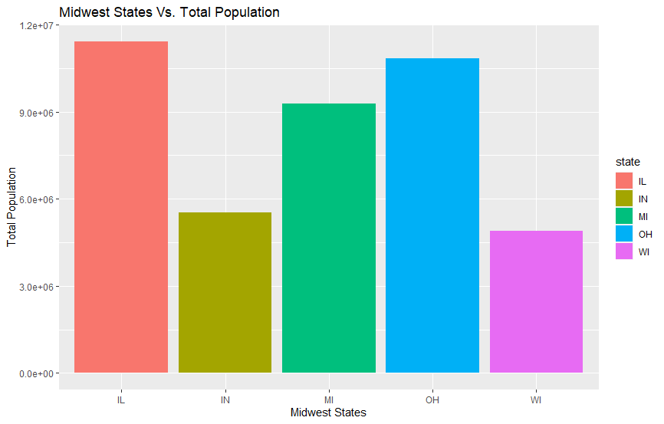](https://user-images.githubusercontent.com/76181662/162102910-657ac0ba-8048-4a8a-9f5c-3270b9304da0.jpeg) [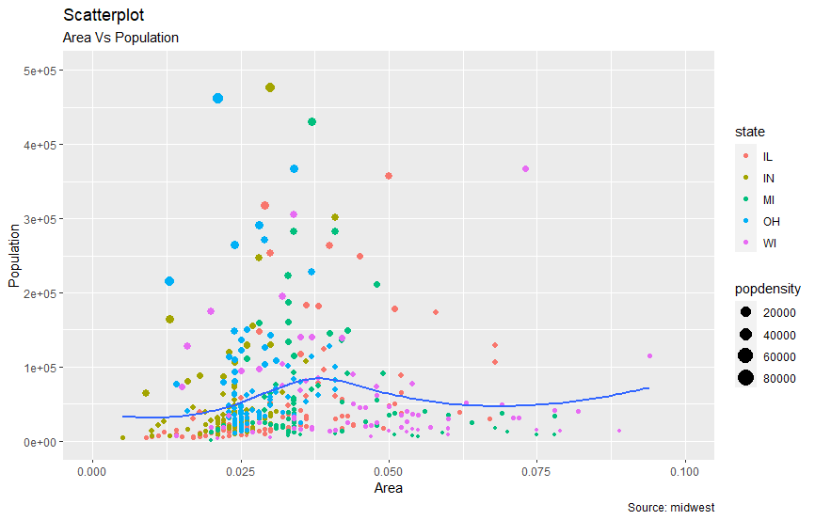](https://user-images.githubusercontent.com/76181662/162102922-f4eaf88f-4f97-4a40-bc89-a674c1f06229.jpeg) [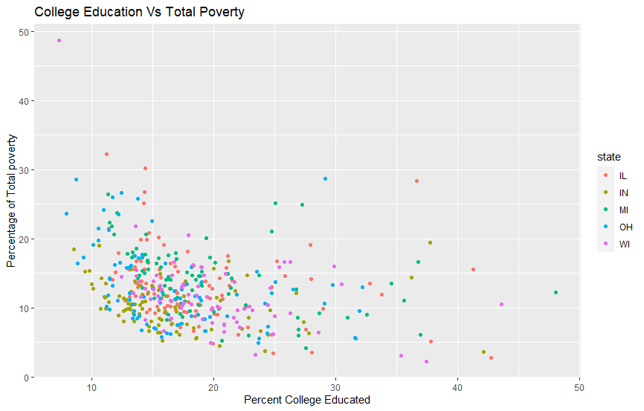](https://user-images.githubusercontent.com/76181662/162102932-2b0da675-67aa-40e1-800a-f5662274bc6d.jpeg) [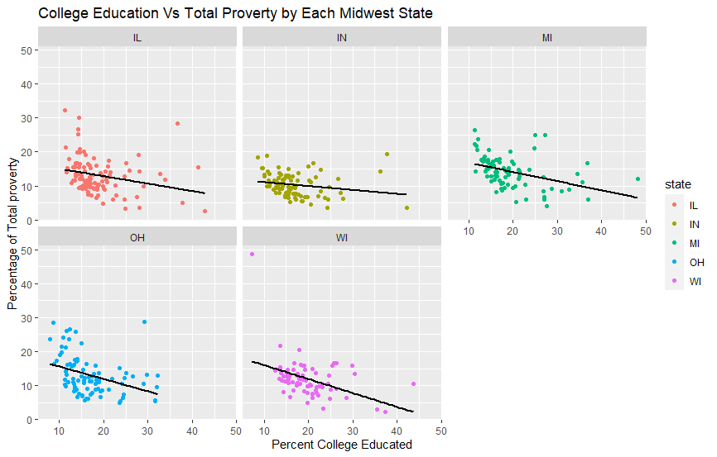](https://user-images.githubusercontent.com/76181662/162102942-9fc0849c-2817-40e0-b512-06ce9b484b72.jpeg) [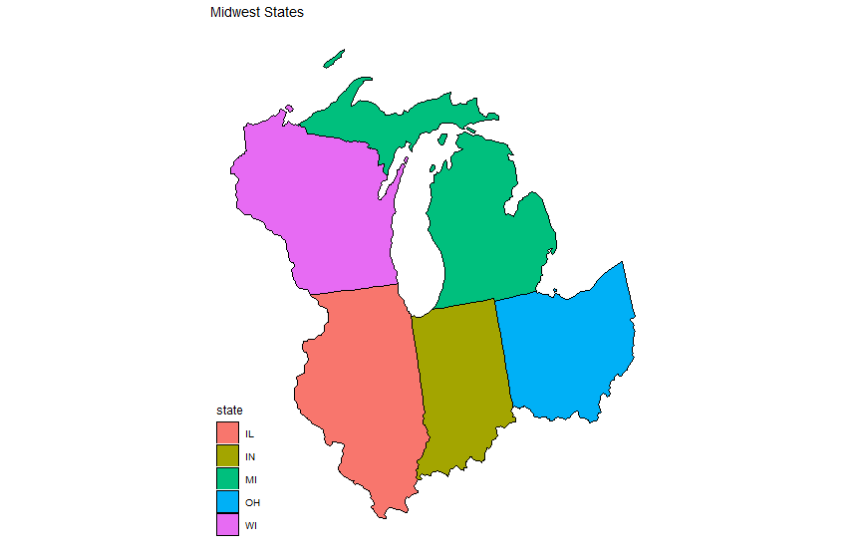](https://user-images.githubusercontent.com/76181662/162102944-20537e8d-2393-4453-b073-2b05a59057f5.jpeg) While I was working on this project, two of the most memorable erros that came up were "Error in +xlab("Midwest States") : invalid argument to unary operator" and "Error in loadNamespace(x) : there is no package called ‘usmap’". Both errors had me stumped but after some googling and looking at Stackoverflow I finally found out that "The '+' operator can be used at the end of lines, but not at the beginning.". In my code I had moved some of my code down a line and I had not left a + operatoer at the end of the line. After I found the solution I quickly implemented it into my code and it complied and my graph loaded. I knew the second error had something to do with how I installed the packages I was using and since I had never used Rs package manager before I googled how to install new packages in the terminal and do it manually. I then came accross the original creater of the package answering the exact question I needed on Stackoverflow. I then copied the terminal command and my graph and code complied successfully.

* Homework Task 1
* [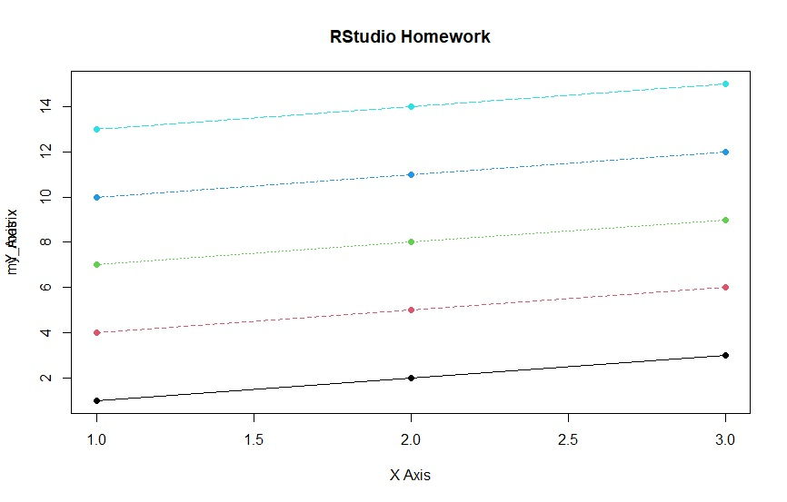](https://user-images.githubusercontent.com/76181662/162053714-0396947f-0068-45fe-8641-986dbf1b456a.jpg)
* 3
* [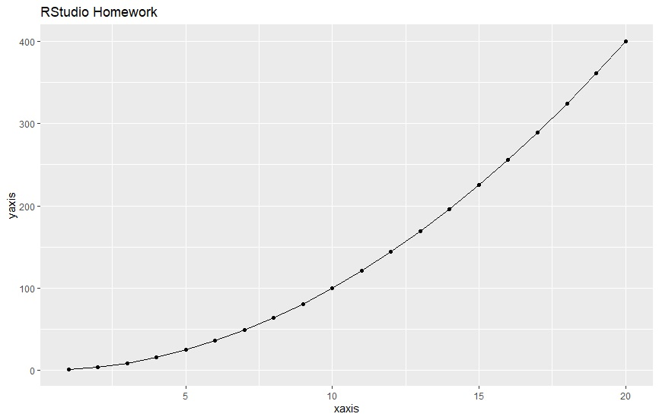](https://user-images.githubusercontent.com/76181662/162053777-f0b4634c-0a39-4eda-bf3d-4d6afd19cf5f.jpg)
* 4
* [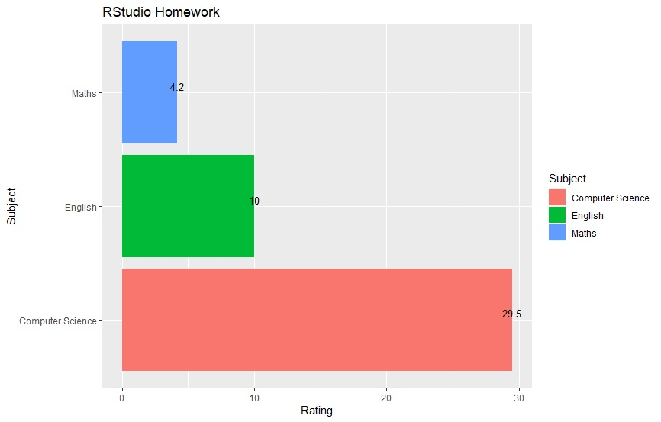](https://user-images.githubusercontent.com/76181662/162053790-e02e220f-d283-4e68-a9e6-d69ff8c6ebd1.jpg)